Q-Docs™Pharmaceutical Document Management System
Product Brochure | Feature & Workflow Overview

1. Executive Overview
Q-Docs™ is a purpose-built, enterprise-grade Pharmaceutical Document Management System (DMS) designed to meet the complex regulatory, operational, and quality requirements of pharmaceutical, life sciences, and other regulated industries. It provides a centralized, secure, and fully auditable platform for managing Standard Operating Procedures (SOPs), policies, quality manuals, regulatory documents, and controlled records throughout their entire lifecycle.
Developed with FDA 21 CFR Part 11 and EU Annex 11 compliance at its core, Q-Docs ensures that electronic records and electronic signatures are legally defensible, tamper-proof, and inspection-ready at all times. Every user action—whether document creation, review, approval, access, revision, or printing—is automatically captured with complete traceability, ensuring data integrity and accountability.
Q-Docs goes beyond traditional document repositories by embedding workflow automation, role-based governance, controlled versioning, and advanced print control directly into day-to-day quality processes. The system enforces standardized procedures across departments while maintaining flexibility to adapt to organizational structures and regulatory expectations.
To further enhance efficiency and decision-making, Q-Docs integrates AI-powered document intelligence, enabling rapid understanding of complex documents through summaries, risk highlights, action points, and change analysis—without compromising compliance or control. These insights support reviewers, approvers, QA teams, and management in making informed, timely decisions.
Scalable, secure, and deployment-flexible (on-premise, cloud, or hybrid), Q-Docs™ serves as a single source of truth for controlled documents, helping organizations reduce compliance risk, accelerate approvals, improve operational transparency, and confidently navigate regulatory audits and inspections.
In essence, Q-Docs transforms document management from a compliance burden into a strategic, intelligent, and governance-driven digital quality system.
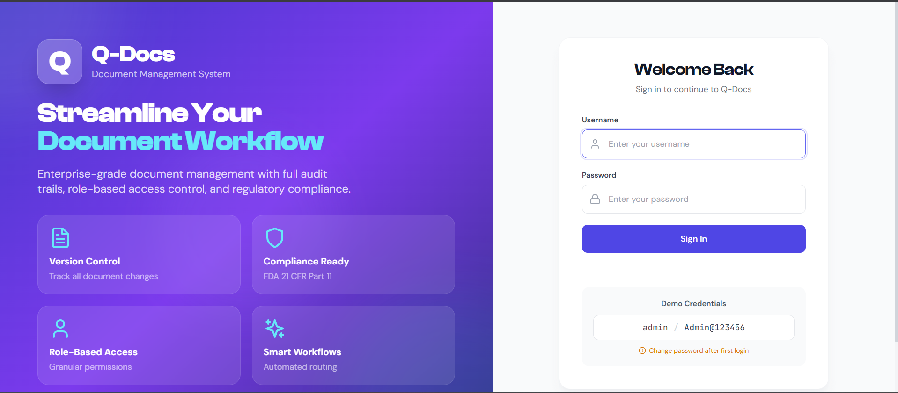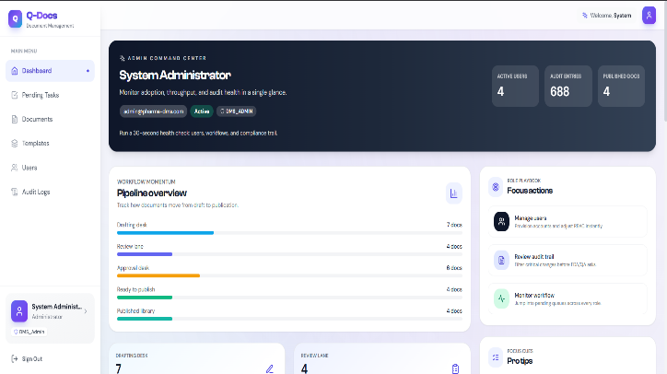

2. Product Vision & Purpose
The primary objective of Q-Docs is to:
- Eliminate manual, paper-based, and fragmented document processes
- Enforce standardized, auditable workflows across the organization
- Ensure complete traceability, accountability, and data integrity
- Reduce compliance risk during audits and inspections
- Improve operational efficiency through automation and AI intelligence
Q-Docs serves as a single source of truth for all controlled documents.

3. System Overview – How Q-Docs Works
Q-Docs manages documents through a structured, rule-driven lifecycle, ensuring governance at every stage.
Document Lifecycle Flow
- Authoring – Documents are created using approved templates and metadata
- Review – Assigned reviewers provide inline comments and recommendations
- Approval – Authorized approvers apply compliant electronic signatures
- Publication – Documents become effective and available for use
- Control – Access, printing, and usage are strictly governed
- Revision – New versions follow the same controlled workflow
- Archival / Obsolescence – Superseded documents are restricted, not deleted
Each action is time-stamped, role-validated, and permanently logged.
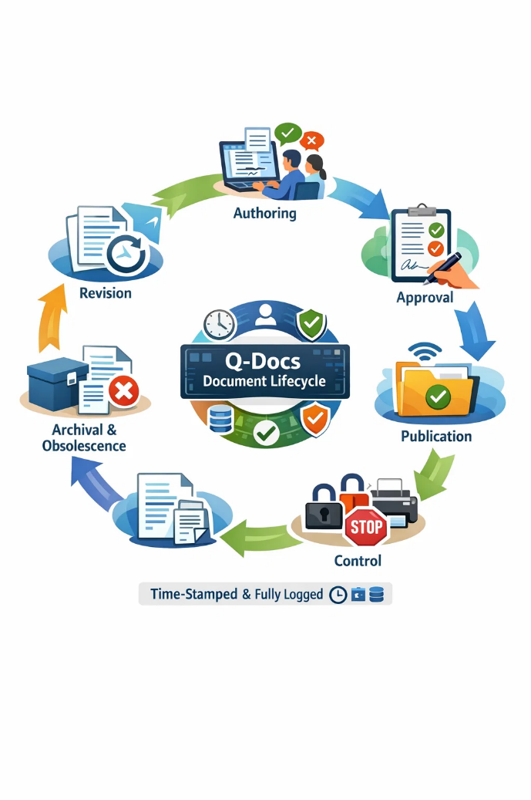

4. User Management & Access Control
Q-Docs enforces strict segregation of duties through role-based access control.
Key Capabilities
- Predefined roles: Admin, Author, Reviewer, Approver, QA, Auditor, HOD
- Context-aware permissions based on document status
- Department-level visibility controls
- Restricted access to archived and obsolete documents
Business Value
- Prevents unauthorized access
- Supports regulatory expectations for accountability
- Ensures users interact only with appropriate document versions
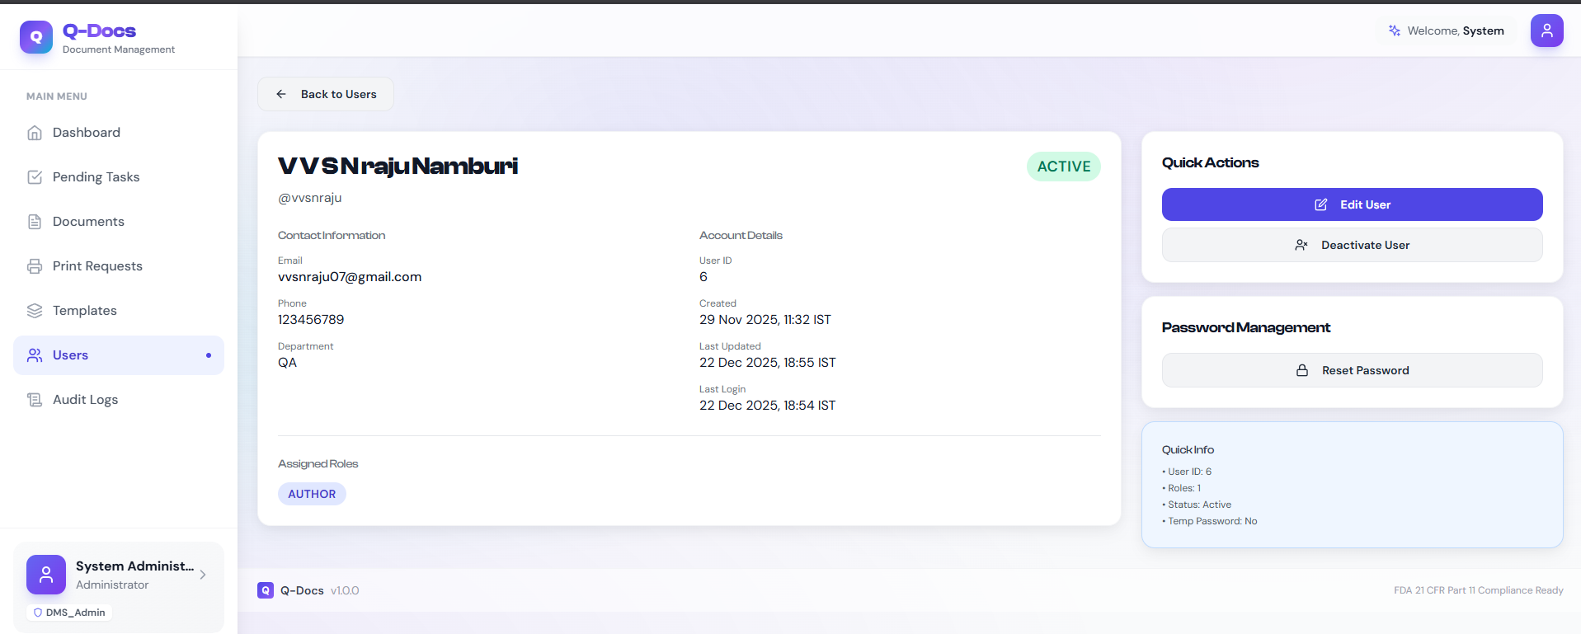
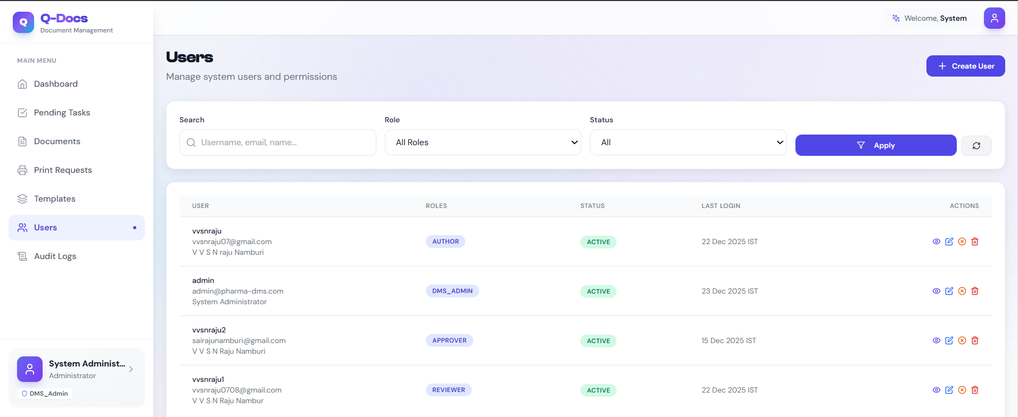

5. Document Authoring & Repository Management
Q-Docs provides a structured environment for creating and managing documents.
Core Capabilities
- Rich-text SOP authoring using a standardized editor
- Mandatory metadata capture for traceability
- Centralized, searchable document repository
- Advanced filtering by status, department, owner, and dates
Outcome
Documents are consistent, traceable, and easy to retrieve during daily operations and audits.
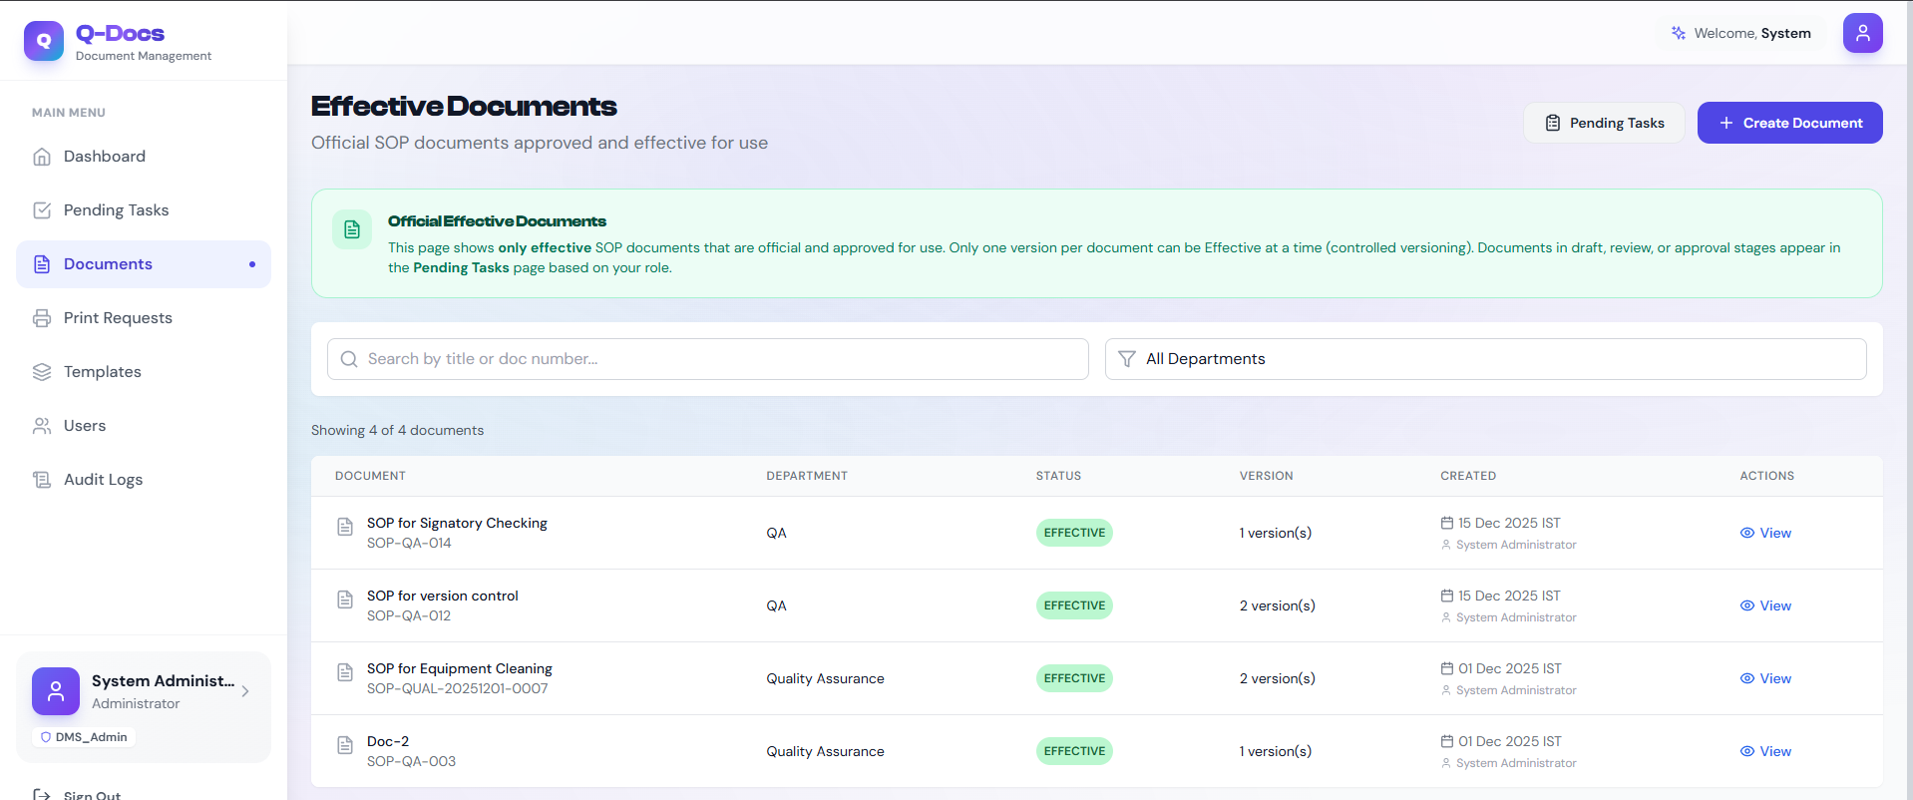

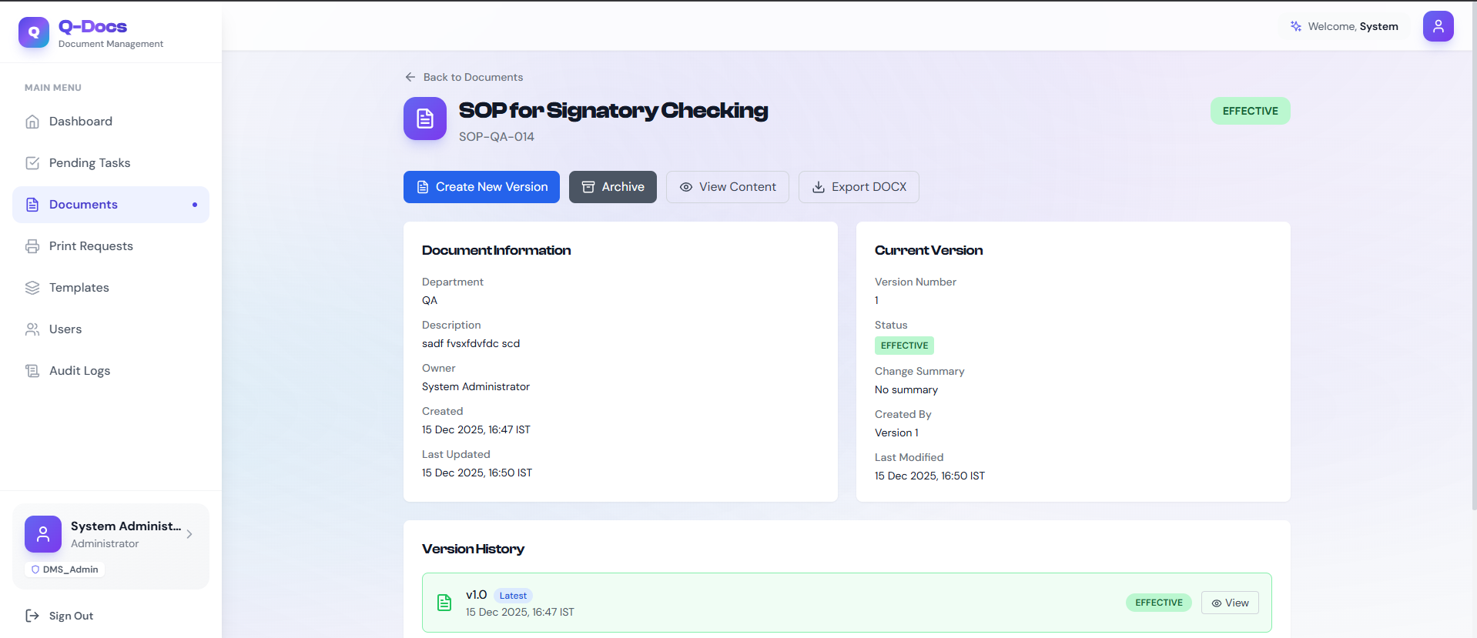
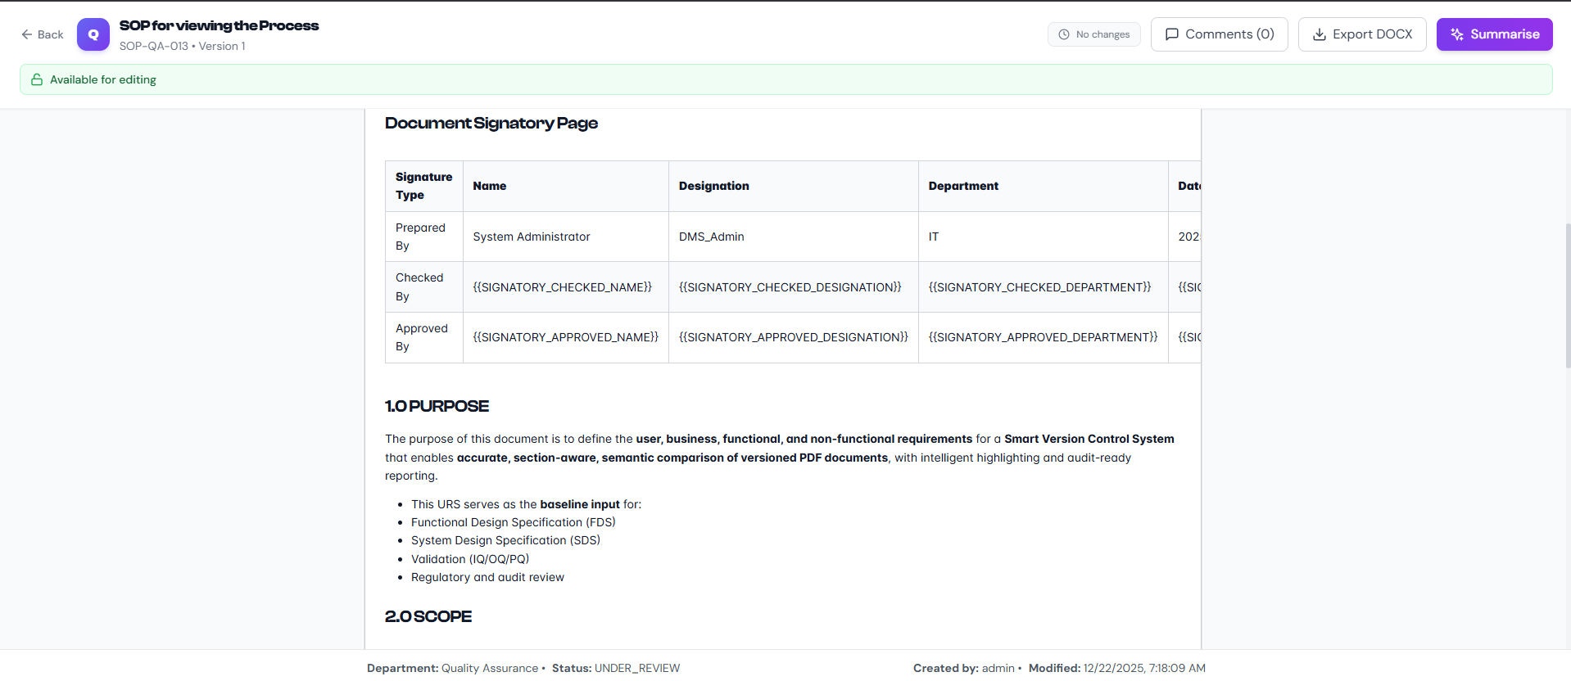

6. Version Control & Change Governance
Version control in Q-Docs is automatic, controlled, and auditable.
Key Capabilities
- Automatic version creation on content changes
- Major / Minor / Patch change classification
- Change justification and impact tracking
- Side-by-side version comparison
- Controlled rollback and restoration
- Automatic obsolescence of superseded versions
Outcome
Users always work with the current effective version, eliminating operational and compliance risk.
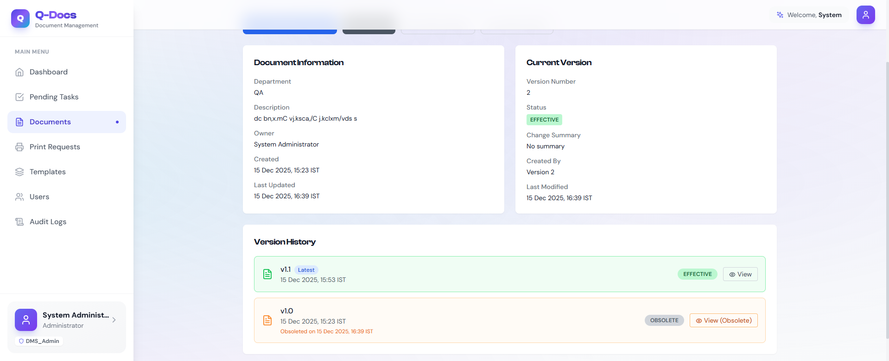

7. Workflow Automation & Approvals
Q-Docs replaces manual follow-ups with rule-driven workflow automation.
Standard Workflow States
- Draft
- Under Review
- Pending Approval
- Published
- Archived
- Obsolete
Workflow Benefits
- Configurable reviewers and approvers
- Parallel and sequential approvals
- Automated notifications and task dashboards
- Escalation for overdue actions
This ensures predictable, repeatable, and compliant approvals across departments.

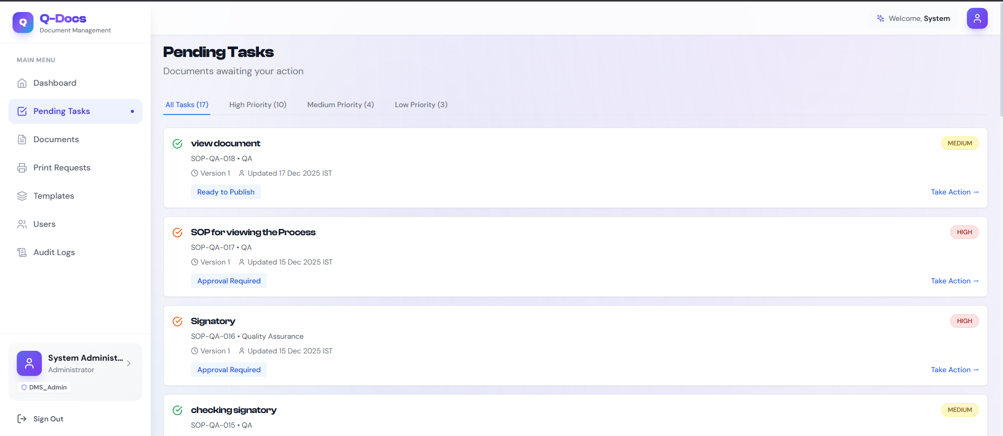
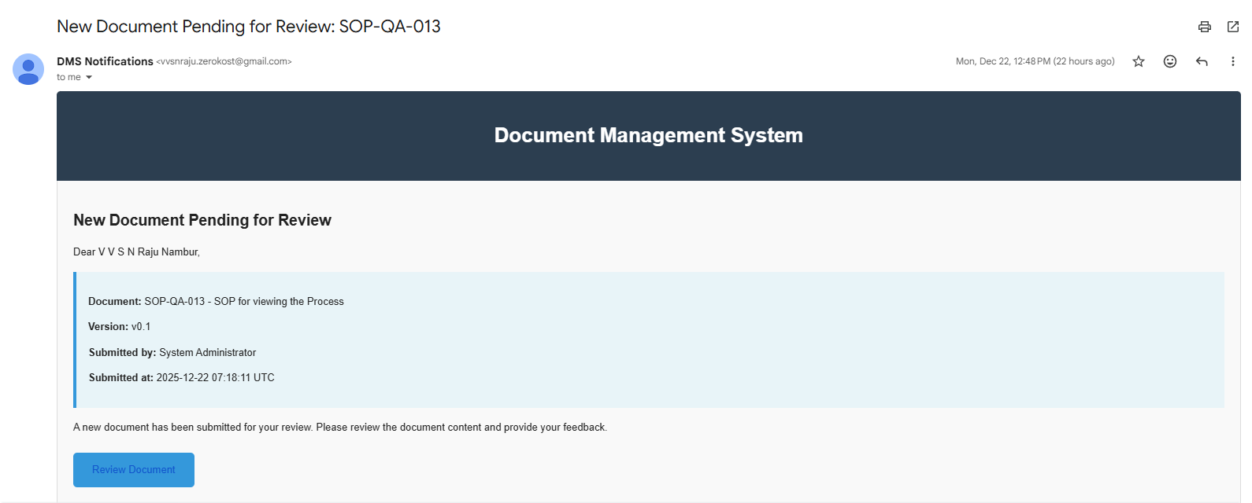

8. Electronic Signatures & Regulatory Compliance
Q-Docs provides fully compliant electronic signatures aligned with regulatory expectations.
Signature Features
- Password-authenticated electronic signatures
- Capture of signer identity, timestamp, IP address, and intent
- Immutable signature records
- Auto-generated signatory tables within documents
Compliance Outcome
Electronic records and signatures meet legal equivalence and non-repudiation requirements under FDA 21 CFR Part 11.
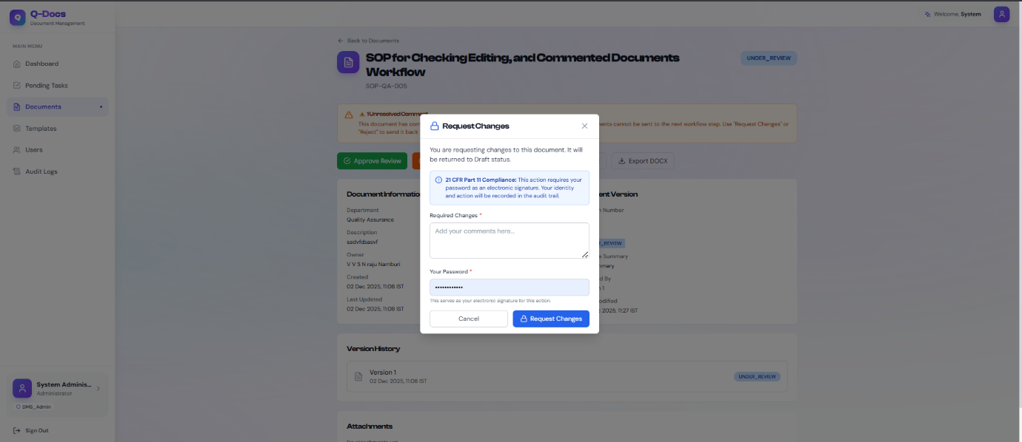
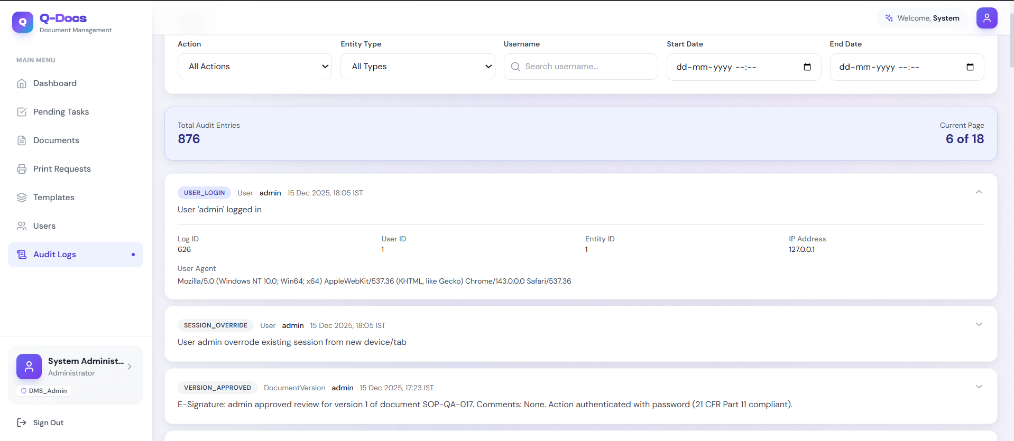

9. Collaboration & Review Management
Q-Docs enables structured collaboration during document review.
Capabilities
- Inline comments linked to specific text
- Comment resolution and tracking
- Role-based commenting rights
- Full audit trail of review discussions
This results in faster reviews, clearer accountability, and reduced rework.
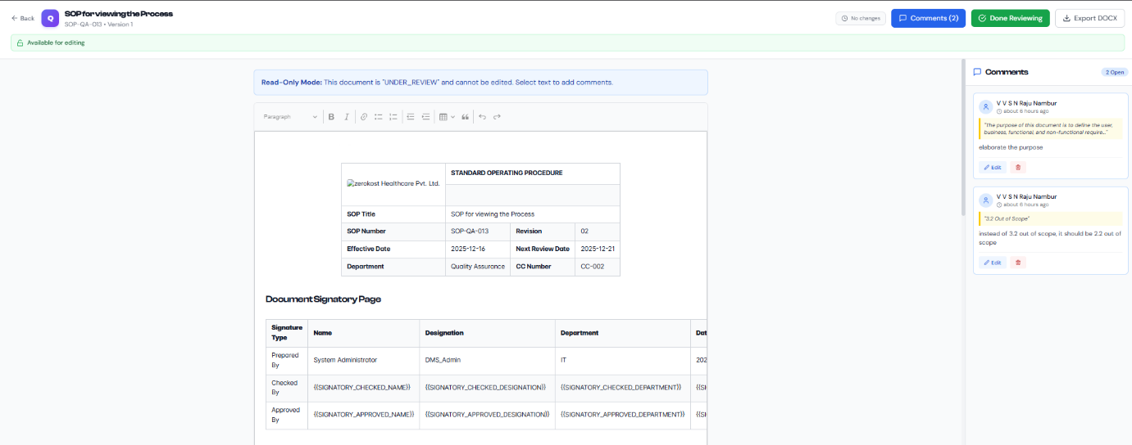
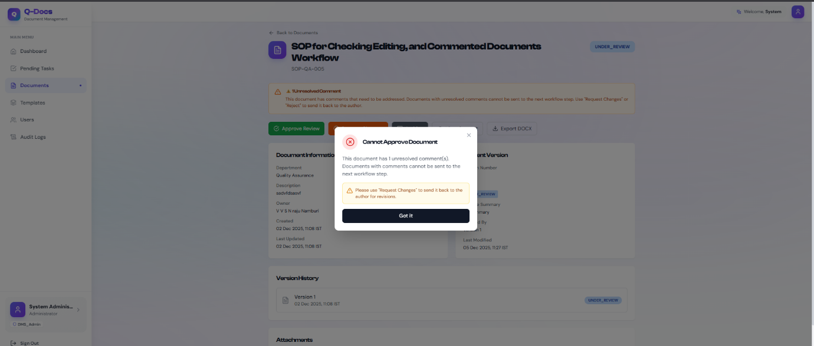

10. AI-Powered Document Intelligence
Q-Docs integrates AI-driven insights to assist reviewers, approvers, and QA teams.
AI Capabilities
- One-click document summaries
- Extraction of key points and action items
- Risk and compliance highlight identification
- Version-to-version change analysis
Operational Advantage
AI insights are generated once, stored securely, and reused, improving efficiency without compromising consistency or compliance.
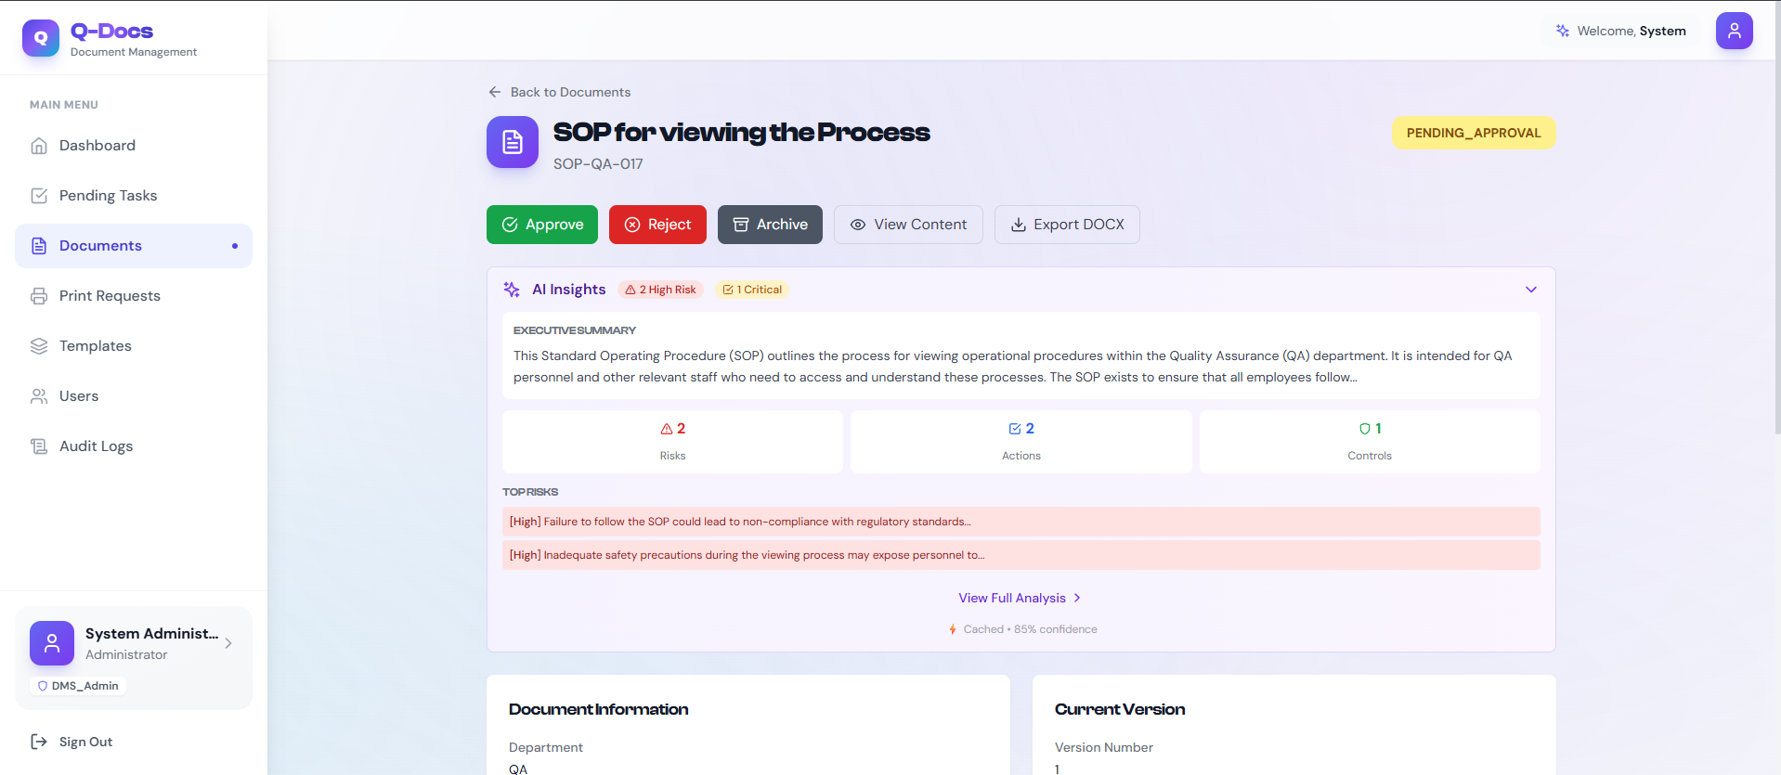

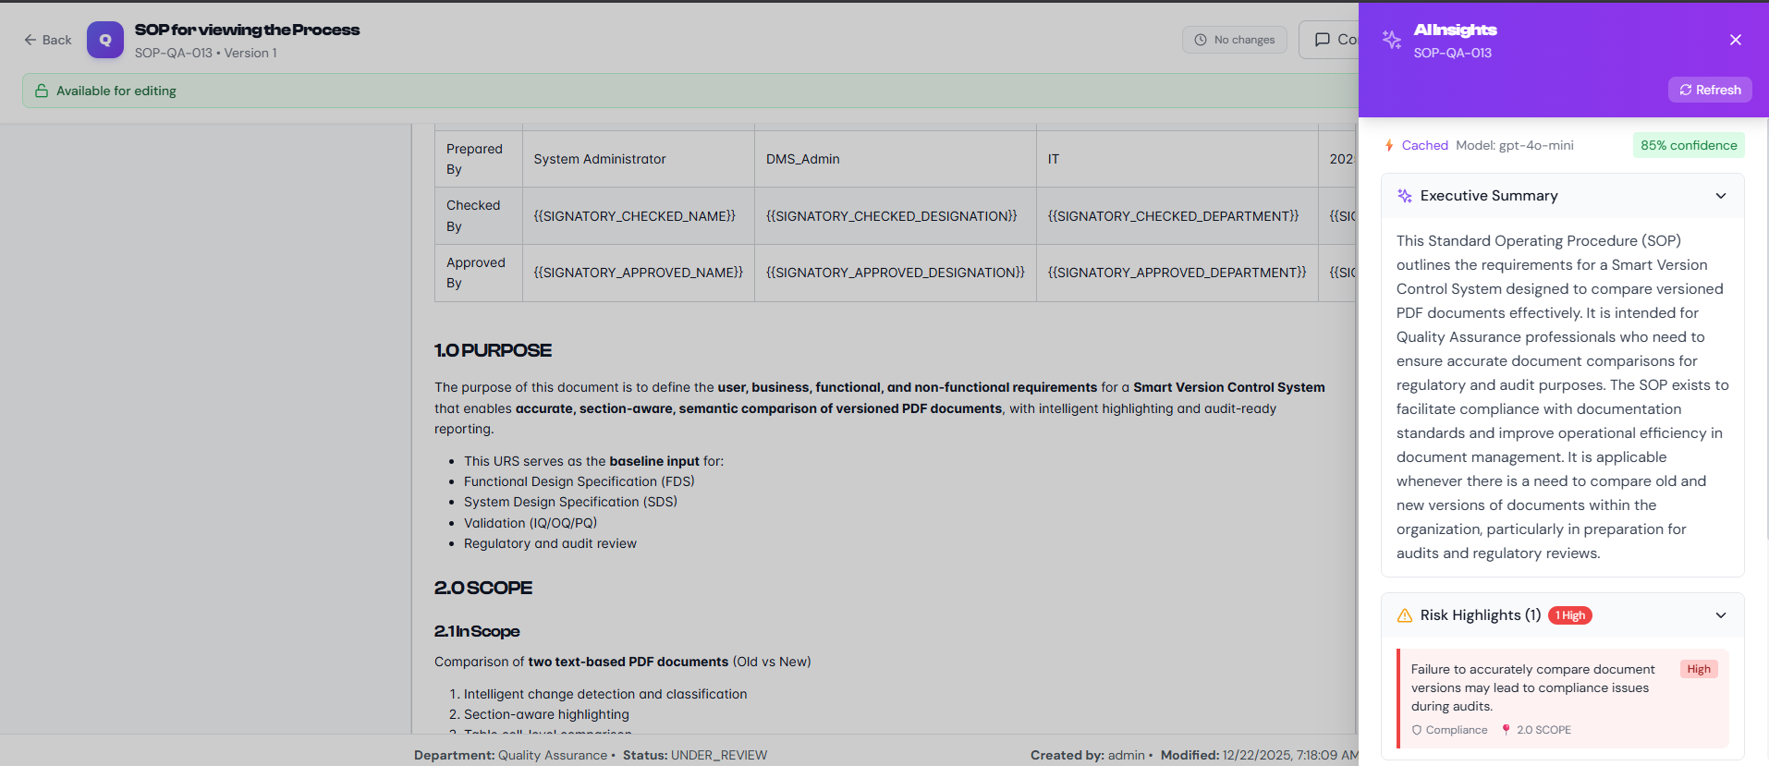

11. Controlled Printing & Physical Copy Governance
Printed documents pose a major compliance risk in regulated environments.
Q-Docs addresses this with end-to-end print control.
Print Control Features
- Approval-based print requests
- Secure print tokens
- Watermarking of printed copies
- Copy issuance, acknowledgment, and destruction tracking
- Immutable print audit logs
Every physical copy is accounted for throughout its lifecycle.

12. Audit Trails & Inspection Readiness
Q-Docs maintains complete, immutable audit trails across the system.
Logged Activities
- Document creation and modification
- Workflow transitions
- Electronic signatures
- Print events
- User access and system actions
Audit Benefit
- Instant audit readiness
- Reduced inspection preparation effort
- Configurable retention (7+ years for pharma)
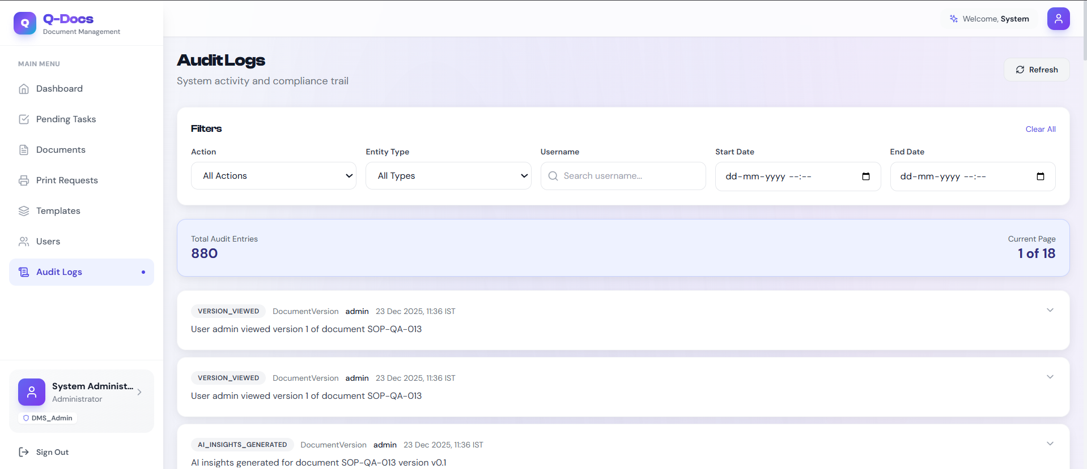

13. Dashboards & Operational Visibility
Q-Docs provides role-specific dashboards for operational clarity.
Examples
- Authors: Drafts and pending comments
- Reviewers: Documents awaiting review
- Approvers: Pending approvals
- QA/Admin: System-wide compliance view
Dashboards support data-driven oversight and proactive quality management.
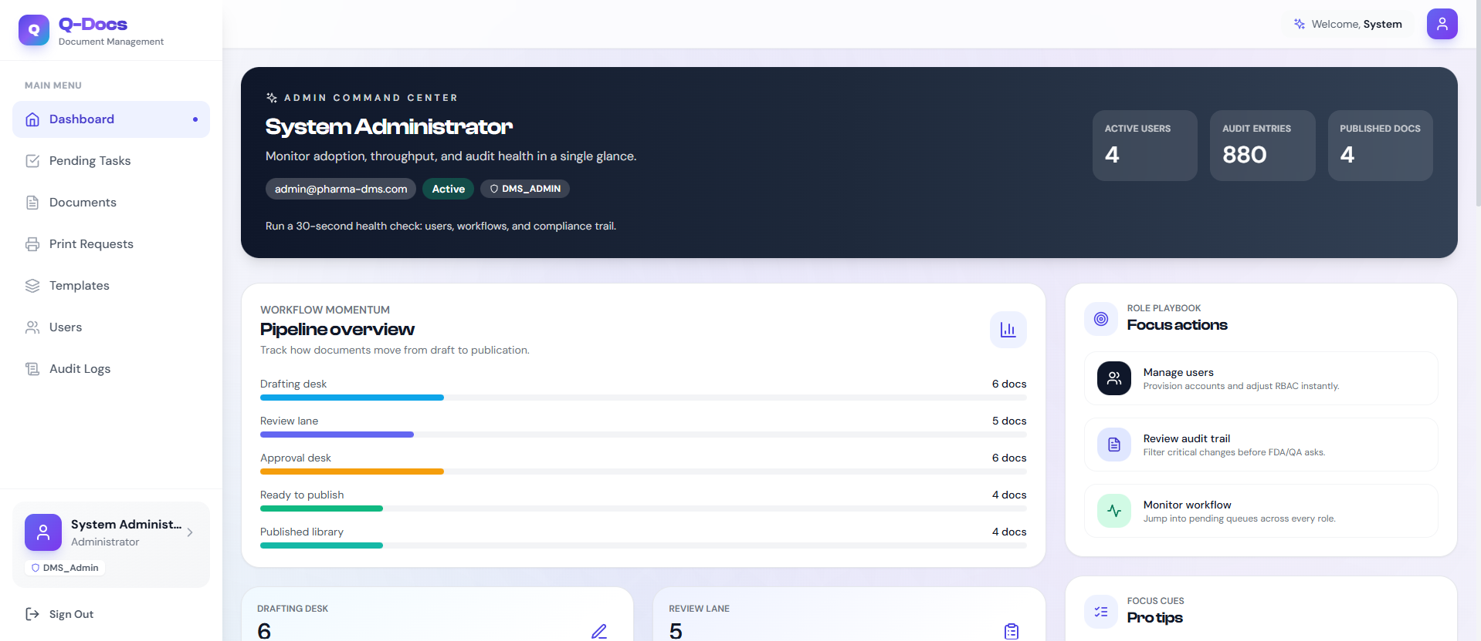
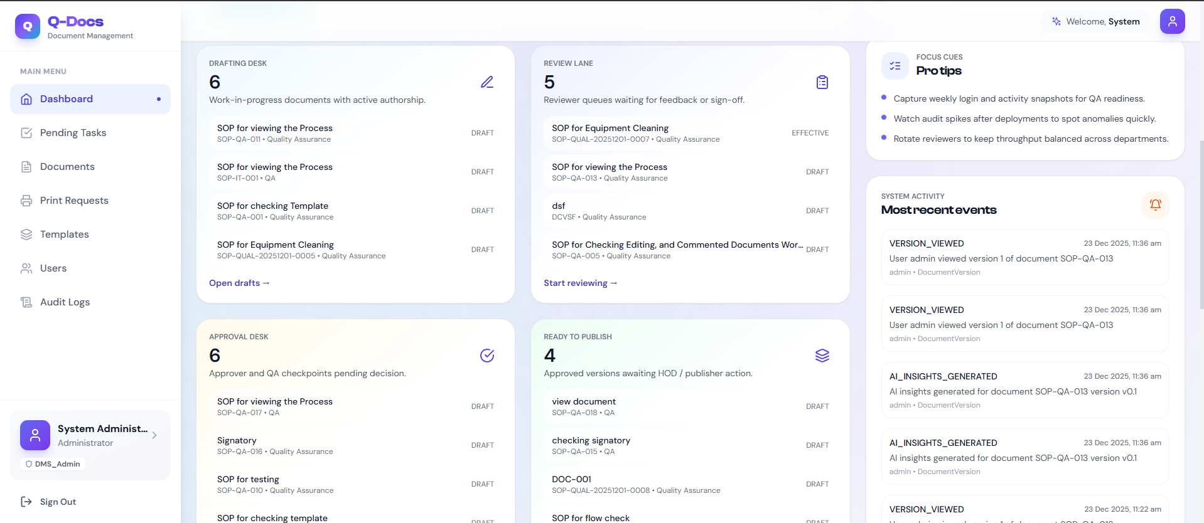

14. Deployment & Scalability
Q-Docs is designed for enterprise deployment flexibility.
Deployment Models
- On-Premise – Maximum data control
- Cloud – Scalability and availability
- Hybrid – Flexible compliance strategies
Built on a modern stack (FastAPI, React, PostgreSQL), Q-Docs scales with organizational growth.

16. Conclusion
Q-Docs™ is a comprehensive, compliance-first Document Management System designed specifically for pharmaceutical and regulated industries.
By combining strict regulatory alignment, workflow automation, advanced version control, AI-driven intelligence, and enterprise-grade security, Q-Docs provides organizations with a robust digital foundation for quality and compliance management.

Q-Docs™
A Trusted Platform for Controlled Documents, Compliance, and Quality Excellence

